**DATA BASE MANAGEMENT SYSTEM FOR WEB APPLICATION(CSA0555)**

**1.IF,ELSIF,ELSE**

DECLARE

v_num NUMBER := 10;

BEGIN

IF v_num < 10 THEN

DBMS_OUTPUT.PUT_LINE('Less than 10');

ELSIF v_num = 10 THEN

DBMS_OUTPUT.PUT_LINE('Equal to 10');

ELSE

DBMS_OUTPUT.PUT_LINE('Greater than 10');

END IF;

END;

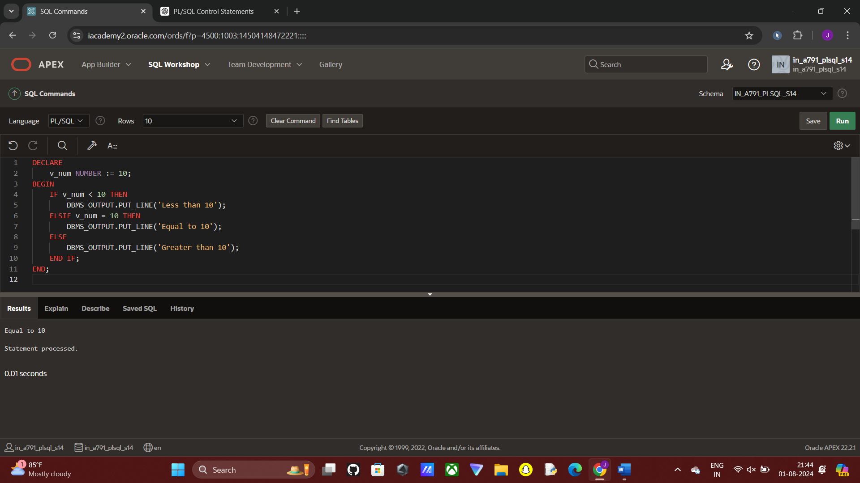

**2.LOOP,WHILE,FOR**

DECLARE

v_counter NUMBER := 1;

BEGIN

LOOP

DBMS_OUTPUT.PUT_LINE('Counter: ' || v_counter);

v_counter := v_counter + 1;

EXIT WHEN v_counter > 5;

END LOOP;

END;

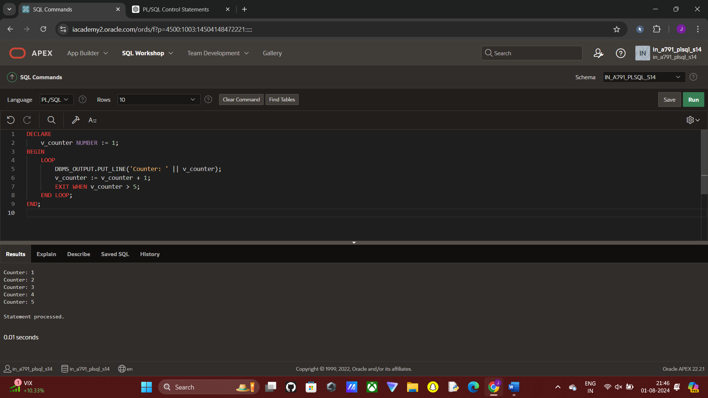

**3.EXCEPTION HANDLING**

BEGIN

RAISE NO_DATA_FOUND;

EXCEPTION

WHEN NO_DATA_FOUND THEN

DBMS_OUTPUT.PUT_LINE('No data found exception handled');

WHEN OTHERS THEN

DBMS_OUTPUT.PUT_LINE('Other exceptions handled');

END;

